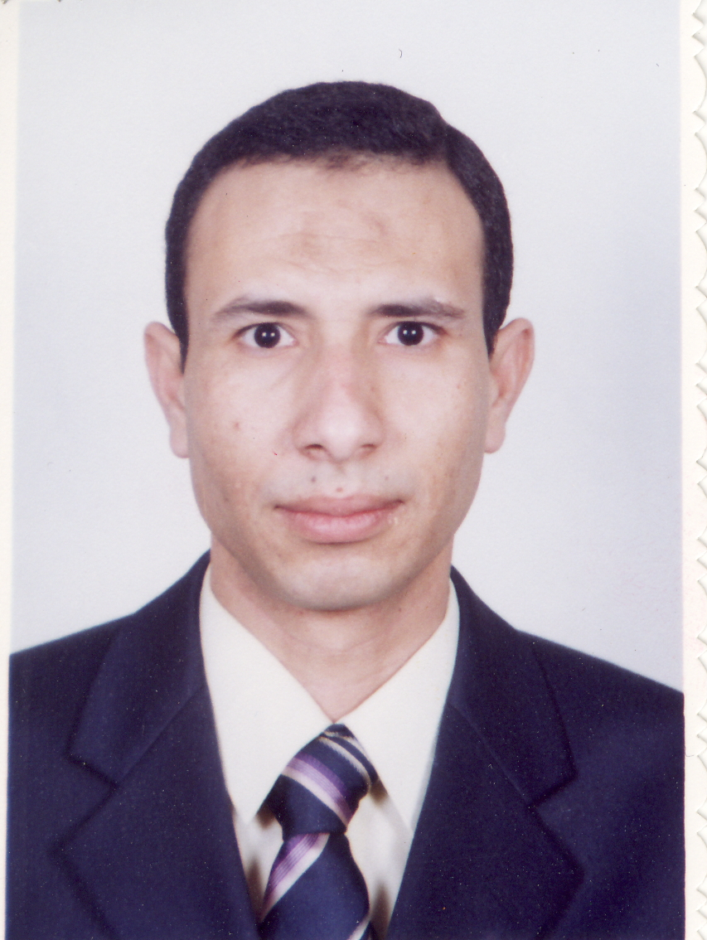
C.V. (Curriculum Vitae)

Personal Data:

Name | : | Farag Kamel Abo-Elusr Mostafa
Address | : | Electrical Engineering Department, Faculty of Engineering, Assiut University, Assiut, Egypt.
Current Job | : | -Assistant lecturer  -Ph. D student, Assiut University, Egypt
Citizenship | : | Egyptian
Date of Birth | : | January, 07, 1978-Assiut, Egypt.
Marital status | : | married
Language | : | Arabic (native), English
E_mail | : | farag@aun.edu.eg
Home Tel. | : | +20 88 2937 299
Work Tel. | : | +20 88 2334688
Fax | : | +20 88 2332553
Passport no. | : | A05767186

Skills:

TOEFL Score | : | 563 marks
Software | : | Matlab programming, Ansoft Simplorer, Fortran Programming
ICDL | : | Valid

Education:

- B.Sc (2000) in Electrical Engineering Department, Assiut University, Assiut, Egypt, with cumulative average grade very good with honor degree.
- M. Sc final presentation (2005) in (SPEED CONTROL OF SHADED-POLE INDUCTION MOTOR)

Experience:
* Employment History:
- Working as a demonstrator at the Electrical Engineering Department, Assiut University, Assiut, Egypt during the period 2000 till November 2005.
- Working as assistant lecturer from November 2005 till now.
-Part time engineer in Korean Electro-Technology Research Institute (KERI) from 9/9/2007 till now (on leave from Assiut University).
-Training in Assiut Company for petrol refining (1/8/1997 to 31/8/1997)
*Course Taught:
Assisted in teaching the following undergraduate courses:
- Introduction of Computer science (Prep. Year)
- Electric circuit (2) (2nd Year)
- Numerical analysis (2nd Year)
- Electric machine (1) (2nd Year)
- Electric machine (2) (3rd Year)
- Special machines (2) (4th Year)
- Electric machine, Measurements and Instrumentation Labs (2nd Year)
- Electrical power systems (3rd Year)
- Electrical energy conversion (3rd Year)
- Power electronic, high voltage and electric machine labs (3rd Year)
- Power system control (4th Year)
- Power system stability (4th Year)
- Power system analysis (4th Year)
- Power system Switchgear and Protection (4th Year)

*Co-Supervising Research Projects):
-Assisted in supervising B.Sc. projects for undergraduate students (power & machinery section):
- Load Flow Study (May 2002).
- Vector Control of 3-phase induction machine (May 2003)
- Active Filter simulation (May 2004)
- Speed Control of 3-phase Linear Motor Using PLC Programming (May 2005).
- PLC control approaches of mixer device (June 2007).
- High voltage power supply, KERI, South Korea, (Sept. 2007-March. 2008).
- Magnetic Levitation Systems, KERI, South Korea, (March. 2008- March 2009).

Publications:

1 | : | A-R. A. M. Makky, Nabil A. Ahmed, Farag Abo-Elusr, " Speed Control of Shaded-Pole Motor", Al-Azhar University Engineering Journal, AUEJ, Vol. 8, No. 3, Cairo, Egypt, Jan. 2005.
2 | : | Farag K. Abo-Elusr, A-R. A. M. Makky, Nabil A. Ahmed, Hyun Woo Lee, Mutsuo Nakaoka, "Speed Control Implementation of Shaded-Pole Induction Motor", International Appliance Technical Conference & Exhibition, IATC, Vol. 57, Chicago, USA, March 2006.
3 | : | Ahmed M. Eid, Farag K. El-usr, Ki-Young Suh, Hyun Woo Lee, Mutsuo Nakaoka, " Engine-Driven Permanent Magnet Single-Phase Linear Synchronous Generator and Its Performance Evaluations", International Appliance Technical Conference & Exhibition, IATC, Vol. 57, March 2006, Chicago, USA, March 2006.
4 | : | Farag K. Abo-elusr, Hiroyuki Ogiwara, Hisayuki Sugimura, Hyun Woo Lee, Mutso Nakaoka “ Pulse Density Modulated Soft-Switching Series Resonant Inverter for High-frequency Induction Heated Roller wih Working Coil”, The International Conference on Electrical Machines and Systems, ICEMs, Nov. 2006, Nagasaki, Japan.
5 | : | Farag K. Abo-elusr et al., “A Literature Survey On High Frequency Production Techniques For Induction Heating Applications", Engineering Conference for young Researchers, EM³AC07, May-2007, Assiut University.
6 | : | F. Abo-Elusr, Speed Control of Shaded-Pole Induction Motor, Elect. Eng. Dept., Assiut University, Assiut, Egypt, 2005. [ M. Sc. thesis]
7 | : | Farag K. Abo-elusr et al , "Performance evaluation of AC/DC PWM converter for 12-phase stand-alone PMSG with maximum power extraction", ICEMs, IEEE conference, Incheon, Korea, Nov. 2010.
8 | : | Farag K. Abo-elusr et al., "Accurate Modeling of Prismatic Type High Current Lithium-Iron-Phosophate (LiFePO4) Battery for Automotive Applications; Energy and power Engineering (EPE) journal, Scientific Research Publisher, Vol. 4, No. 6, Nov. 2012.
9 | : | Farag K. Abo-elusr et al., "Characterization and Effectiveness of an Ultracapacitor Bank to Enhance a Battery Electric Vehicle Energy Storage System Dynamics", ICEMs, IEEE conference, Busan, Korea, Oct. 2013.

Posters:

1 | : | K.J Joo, S.R Jang, Farag Abo-elusr, G. H Rim, “Technical Trends of Electric Vehicle” in Korean, Korean Institute of Electrical Engineers (KIEE), July-2009, Seoul, Korea.

Conferences:

- Al-Azhar University Engineering Journal, AUEJ, Cairo, Egypt, Jan. 2005.
- International Appliance Technical Conference & Exhibition, IATC, March 2006, Chicago, USA, March 2006.
- International Conference on Electrical Machines, ICEMs, October 2010, Incheon, Korea.

Prizes:

-Prof Dr. Ali Hassan El-harras prize for distinct student in Electric Machine (3rd Year).
-Prof Dr. Essmat Badawy prize for distinct student in Electric Power (3rd Year).
-The distinct student over the five years in the faculty of Engineering, Assiut University, Assiut, Egypt.

Referees:

- Prof. Dr. Mazen M. S. Abd-Elsaam, Deputy of Faculty of Eng., Assiut University, Assiut, Egypt. (mazen@aun.edu.eg)
2- Prof. Dr. M. Z. El Sadek, Head of Elec. Eng. Dept., Assiut University, Assiut, Egypt. (Tel 002-088-334688) Fax: 002-088-332553
3- Prof. Dr. A-R.A.M. Makky, Previous Head of Elec. Eng. Dept., Assiut University, Assiut, Egypt. ( a.rmakki@aun.edu.eg )
4- Dr. Nabil A. Ahmed, Assiut university, Lecturer in Elec. Eng. Dept., Assiut University, Assiut, Egypt. (nabil@acc.aun.edu.eg )

